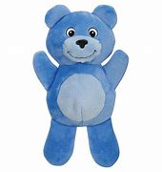
RED BUTTERLY AND BLUE BEAR NEWSLETTER
April 2023

Dear Parents,

Red Butterfly Themes: Blue Bear Themes:
April 3rd-7th Easter Easter
April 10th-14th Sports Week Safari/Zoo
April 17th-21st Free Expression Ocean Life
April 24th-28th A B C Insects

Reminders:
- Thank you for not using your cell phone during drop off and pick up times. Often times we need to talk to you about your child’s day.
- Please remember to check art files daily.
- With all the new jackets and clothing showing up after the holidays we would like to remind everyone to label all child’s clothing so we can keep better track of these items.
- When your child is potty training please help them by dressing them in clothing easy to pull up and down
Sara, Beth, Lisa, Terri, Victoria

