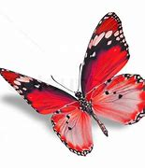
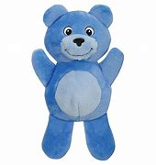
RED BUTTERLY AND BLUE BEAR NEWSLETTER
JANUARY 2022

Dear Parents,
Happy New Year! Welcome to another year with us in the Red Butterfly and Blue Bear rooms! We are excited to be sharing this upcoming time with you and your family. We hope everyone enjoyed their winter Holidays and made new and wonderful memories with your families. We enjoyed hearing the children’s stories of how they spent their vacation time! We want to say a big “THANK YOU” to those that brought the teachers cards, gifts and treats, you made us feel very special!

Red Butterfly Themes: Blue Bear Themes:
January 3rd-7th Winter Solstice Animals/Pets
January 10th-14th Colors (Blue & Yellow) Reptiles
January 17th-21st Letters Air Transportation
January 24th -28th Transportation Ground Transportation
January 31st – 4th Numbers & Songs Birds

Important Dates:
Monday January 17th for Teacher Work Day

Reminders:
- Thank you for not using your cell phone during drop off and pick up times. Often times we need to talk to you about your child’s day.
- Please remember to check art files daily.
- With all the new jackets and clothing showing up after the holidays we would like to remind everyone to label all child’s clothing so we can keep better track of these items.
- When your child is potty training please help them by dressing them in clothing easy to pull up and down.

Sara, Janelle, Lisa, Kelly & Hannah

